OS goals –
• Maximum CPU utilization
• Less process starvation
• Higher priority job execution
Types of Operating Systems:
Single process operating system: MS DOS (1981)
Batch-processing operating system: ATLAS, Manchester University (late 1950s – early 1960s)
Multiprogramming operating system: THE (Dijkstra, early 1960s)
Multitasking operating system: CTSS, MIT (early 1960s)
Multi-processing operating system: Windows NT
Distributed system: LOCUS
Real time OS: ATCS

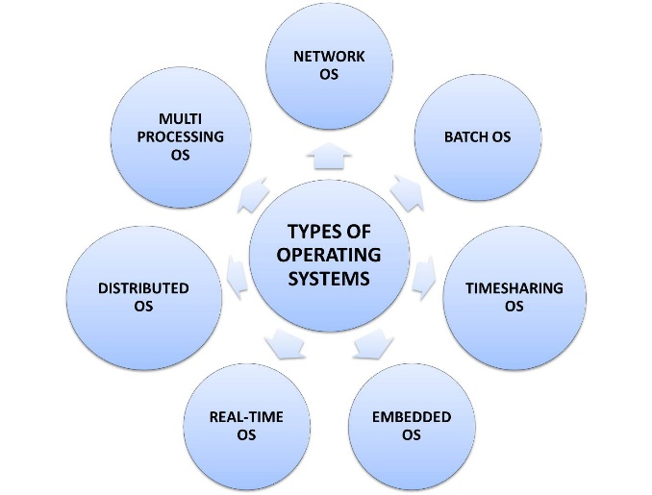

Single process OS:
Only 1 process executes at a time from the ready queue. [Oldest]
Batch-processing OS:
- Firstly, user prepares his job using punch cards.
- Then, he submits the job to the computer operator.
- Operator collects the jobs from different users and sort the jobs into batches with similar needs.
- Then, operator submits the batches to the processor one by one.
- All the jobs of one batch are executed together. - Priorities cannot be set, if a job comes with some higher priority. - May lead to starvation. (A batch may take more time to complete)
CPU may become idle in case of I/O operations.

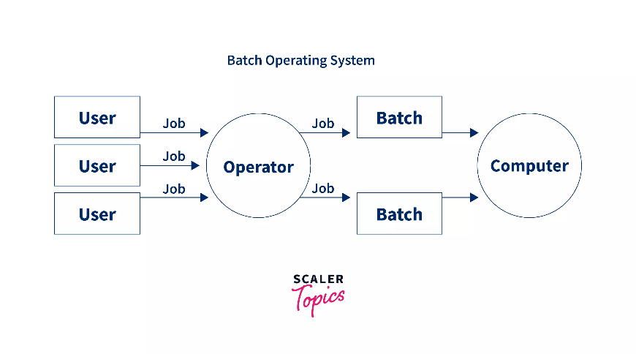

Multiprogramming
Multiprogramming increases CPU utilization by keeping multiple jobs (code and data) in the memory so that the CPU always has one to execute in case some job gets busy with I/O.
- Uses a single CPU.
- Uses context switching between processes.
- Switching occurs when the current process enters a wait state (e.g., for I/O).
- Reduces CPU idle time.

Multitasking
Multitasking is a logical extension of multiprogramming.
- Uses a single CPU.
- Able to run more than one task concurrently (apparently simultaneously).
- Uses context switching and time-sharing techniques.
- Increases system responsiveness for users.
- CPU idle time is further reduced.

Multiprocessing
- Multi-processing OS uses more than 1 CPU in a single computer system.
- Increases reliability; if one CPU fails, others can continue working.
- Provides better throughput (more work done per unit of time).
- Results in lesser process starvation, as processes can be executed on different CPUs simultaneously.
Distributed OS
- An OS that manages many sets of resources, such as ≥1 CPUs, ≥1 memory units, ≥1 GPUs, etc.
- Systems are loosely connected and autonomous, consisting of interconnected computer nodes.
- It is a collection of independent, networked, communicating, and physically separate computational nodes.

RTOS (Real-Time Operating System)
- Performs real-time, error-free computations that must be completed within strict, tight-time boundaries.
- Examples include Air Traffic Control Systems (ATCS), ROBOTS, etc.

